# How to use IScored.Today for scoring

1. Navigate to <https://iscored.today/>
   1. Note you can make this a shortcut (add to Home screen) on your phone

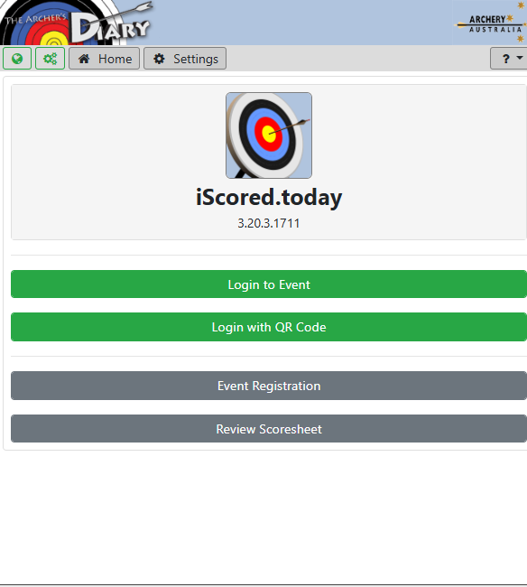

1. For CAC events, we generally only use the “Login to Event” option, so choose that one
2. On the next screen, choose the event from the drop-down menu
   1. Enter the Archers name
   2. Enter the passcode
      1. For CAC events, the format is “CAC” + DDMM, eg CAC2505

Now that only events **for today** will be listed and can be scored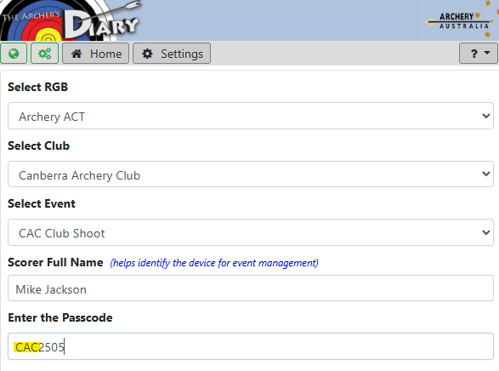

1. Then from the list of registered archers, select those that will be scoring together on your device.
   1. There may be more than just yourself, as you may be entering scores for someone else shooting on your target, or someone on an adjacent target.
   2. Usually it will be just those (1-3) people on your target.
   3. Anyone showing as red/locked has already been selected (by you or someone else)
   4. Then press START

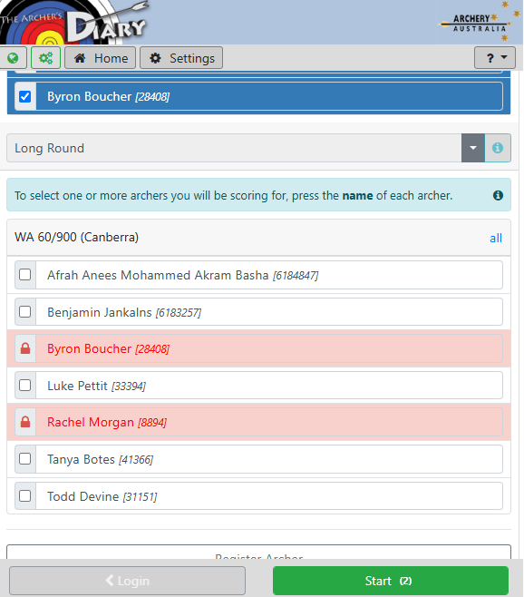

1. Now click on the names to order the scoring
   1. convention is left to right on the line, in the example below Rachel would be standing on the left of Byron
   2. Press Scoring to commence

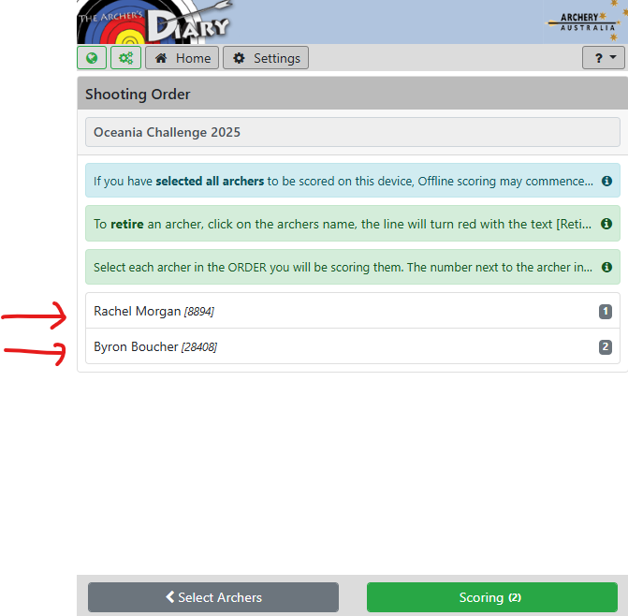

1. Initially you’ll see the progressive score page, so to start scoring press ADD SCORES

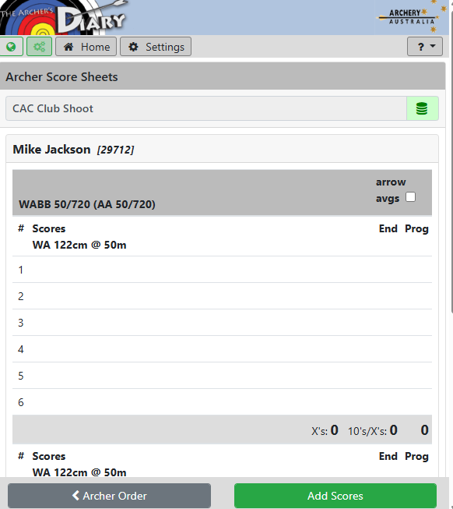

1. Enter the value of each arrow, in descending order
   1. If you’ve made a mistake, you can click the value on the left to remove & replace it
   2. Press NEXT when all 6 arrows are scored, and repeat for the next archer.

